**Viruses, Worms, Trojan Horses.**

Computer viruses have been around for quite a while on the Internet. In the 1980s, for example, viruses were almost exclusively transmitted through diskettes. You had to be constantly vigilant when accepting a diskette from someone you didn’t know.

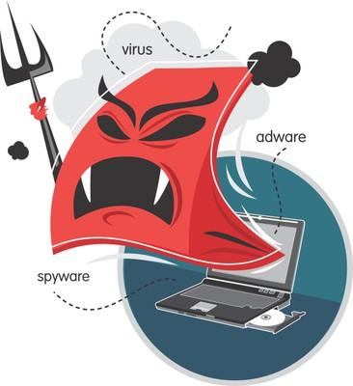

Of course, the Internet is the dream media for spreading all kinds of virtual pests, like viruses and worms. Fortunately, most people are aware of the danger presented by viruses, and many have installed a virus scanner. But what kinds of viruses are there? And what is a worm? What is a Trojan Horse? And should we take care with some virus warnings?

**What is a virus?**

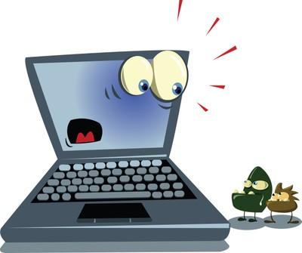

* A virus is a program that **attaches itself to other programs or files.**
* The program is designed **to be able to copy itself.**
* The virus tries to **spread** from one computer to another.
* **It can only spread through the actions of the user**. A virus will not send itself; it infects files, and those files are then forwarded, or passed on for example. When an infected file is opened, the virus goes to work.

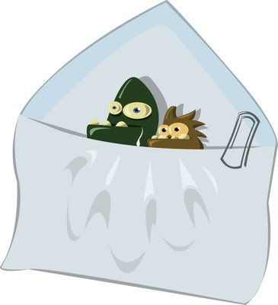

* The virus has access to the computer. The damage it can cause varies from **slightly annoying side effects** (slow computer, windows popping up, change in the PC’s behaviour, etc.) to **sheer destruction** (erasing files, wiping the hard drive, etc.).
* It can, therefore, cause **damage** to software or to the information held in files.

**What is a worm?**

* A worm tries to **spread from one machine to another.**
* As opposed to a virus, a worm does not rely on the actions of the user: the worm can **spread automatically.**
* A worm does not have to attach itself to other files; it is able to spread **independently**. The spreading mechanism is incorporated in the worm.
* Worms try to guide an infected code through any open door to a computer. An Internet connection is often all it takes to become infected with worms.
* Worms can also spread by means of **email addresses** encountered on the infected computer, either in the address book, or on web pages.
* The first thing a worm does is cause an **increase in network traffic**. It makes normal programs run slowly and, in the worst case, stop altogether.
* Worms can also be designed to steal users’ personal information.

**What is a Trojan Horse?**

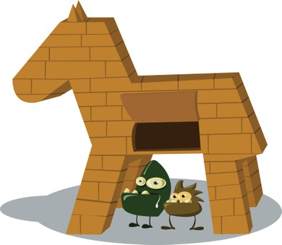

* Like the wooden horse of Troy, a **Trojan** or **Trojan Horse** is a poisoned gift. It is a piece of software attached to a program that was installed by a user.
* At **first sight** it looks like a useful program but, in reality, **it causes damage** to computer data or gathers the user’s information and so constitutes a threat to privacy (e.g. passwords, etc.)
* A Trojan Horse spreads via the Internet,
  + for example as **an attachment** to an email that looks as if it comes from a reliable source (e.g. email from Microsoft containing the latest update for Windows -- or so it claims)
  + or nestled in software that you **download** from the Internet (for ex. "Download this program and make your PC ten times faster!").
* Trojan Horses do not copy themselves independently to other computers. They always require some action on the user’s part, such as installing a program.
* Trojan Horses can take over your computer, discover passwords and user names, share, change or delete files from your computer, turn your computer into a bot, make your computer crash, send out spam and so on.
* A **Trojan horse**, or **Trojan**, is malware that appears to perform a desirable function for the user prior to run or install but instead facilitates unauthorized access of the user's computer system. *"It is a harmful piece of software that looks legitimate. Users are typically tricked into loading and executing it on their systems"*, as Cisco describes.[1] The term is derived from the Trojan Horse story in Greek mythology.  
  Trojan horses are created for the purpose of running code on the user's computer that he otherwise would not have consented to, allowing the author of the Trojan access to a number of personally-desired purposes.  
    
  **Adware**  
  A Trojan horse may modify the user's computer to display advertisements in undesirable places, such as the desktop or in uncontrollable pop-ups, or it may be less notorious, such as installing a toolbar on to the user's Web browser without prior mentioning. This can create the author of the Trojan revenue, despite it being against the Terms of Service of most major Internet advertising networks, such as Google AdSense